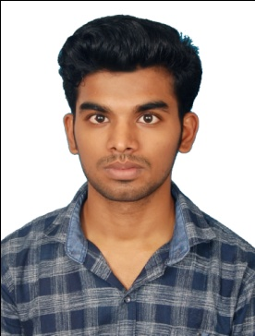**VIJAY P.S**

1, Old Dharmaraja Koil Street,

Tiruttani – 631209

Thiruvallur district, Tamil Nadu

India+91-6382394574

Email: [vijayshiva134@gmail.com](mailto:vijayshiva134@gmail.com)

DOB: 02-10-1996 AGE: 22Male |INDIAN

**Career Objective:**

To pursue a challenging career and to be the part of progressive organisation that gives a scope to enhance my knowledge and utilizing my skills towards the growth of the organization.

**Qualification Credentials:**

|  |  |  |  |  |  |
| --- | --- | --- | --- | --- | --- |
| **Courses** |  | **Institute** | **Board** | **Year** | **Percentage** |
| UG | B.E.  Electrical Engineering | R.M.K. College of Engineering & Technology | Anna University | 2018 | 71% |
| School | Higher Secondary | Vidya Vikas Matriculation Higher Secondary School | State Board | 2014 | 93% |
| Secondary | Bharathidhasanar Matriculation School | State Board | 2012 | 94% |

**Professional Attributes:**

* Logical thinking
* Field working
* Punctual
* Team working
* Problem Understanding and solving

**Preferable Career Interest IT:**

* Frontend Developer
* Java developer

**Mini Project :** Free Energy Generator

**Description :** Device to generate electrical energy by neodymium magnet

**Final Year Project :** LED Drive Circuit used a single stage soft switching device

**Description :** DC bus & switching voltage stress is limited to peak of line voltage.

**Work Shop:**

* ETAP Automation for two days by RMK College of Engineering & Technology
* Image Sensing satellite development for three days by SSN College of Engineering.

**Implant Training:**

* North Chennai Thermal Power Station TANGEDCO (TNEB) Chennai.

**Technical Skills:**

* HTML5(Intermediate)
* CSS (Intermediate)
* JAVASCRIPT(Intermediate)
* CORE JAVA(Intermediate)
* MYSQL(Begineer)
* ANGULAR JS (Beginner)

**Membership in Technical Organization :**

* National Apprenticeship Training Scheme (NATS)
* Indian Society for Technical Education (ISTE)
* The Institution of Electronic and Telecommunication Engineers (IETE)

**Strength:**

* Problem Solver
* Goal Oriented
* Good Team leader

**Hobbies:**

* Online Surveying
* Hearing development motivational speeches
* Listening Music

**Languages known:**

* Tamil (Both read & write) (Mother tongue)
* English (Both read & write)

**DECLARATION**

I hereby acknowledge that the above furnished information is true to the best of my knowledge

Date: Yours Sincerely,

**VIJAY P.S**